Project 2

INDIVIDUAL PROJECT

MARVIN HOPE

219445842

**CONTACT:**

TASK……………………………………………………………………………1

CODING EVIDANCE………………………………………………………….1

* WIRE FRAME…………………………………………………………1.1
* PSEUDO CODE AND FLOW CHART……………………………….1.2
* CODE………………………………………………………..................1.3
* DESIGN………………………………………………………………..1.4
* COLOURS……………………………………………………………..1.5
* FINAL DESIGN……………………………………………..................1.6

REFLECTION………………………………………………………………......2

GITHUB GROUP LINK…………………………..............................................3

GITHUB PERSONAL LINK…………...............................................................4

**TASKS**

The task that was given to me was that I must make a main page in android studios.

The main page will actually contain the CPUT schedules, Stages and time of load shedding. Once the user access my page, it will display the load shedding times and the CPUT students and lectures time tables.

**CODING EVIDENCE:**

For the coding part, we as a group as decided to use android studios because we are developing an app on android.

In the coding section I will display the flow chart and in this section I will also include the functional requirements for the main page.

**FUNCTIONAL REQUIREMENTS:**

* The user will come from the register and login page to the main (Schedule) page.
* Once the user provided a valid email and password, the application will take the user to the main page.
* The main page will also contain the days of the month, Monday to Friday.
* On the main page it will display the stages of load shedding at district 6 campus.
* On the main page, it will display the student subjects and the times when the specific classes start.
* The main will gather all its information from Eskom’s twitter feed, the reason why is because Eskom’s twitter is where there is the latest news about when load shedding will occur and what stage it will be.
* The main page will also contain the City of Cape Town twitter feed because COCT indicates what stage load shedding will occur in Cape Town because Cape Town has different stages of load shedding from the rest of South Africa.
* The main page will also have a push notification for the user to inform the user that there will be load shedding and the notification will also in indicate what stage it will be.
* The main page will also contain a back button where it will take the user back to the previous page.
* The main page will also have a menu button, in the button, it will showcase the other pages on the application.

**WIRE FRAME AND DESIGN:**

In the wireframe section, this is the blueprint of how the Schedule page will look like.

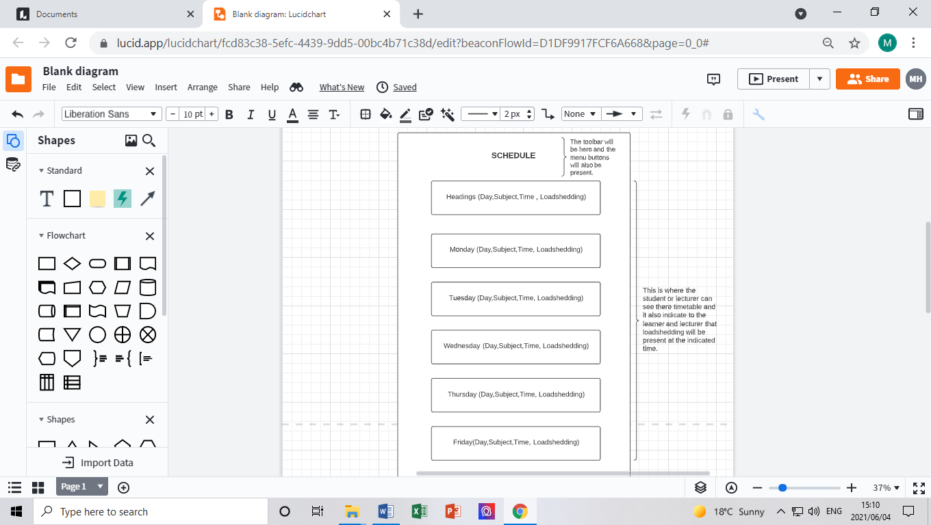

**FLOW CHART:**

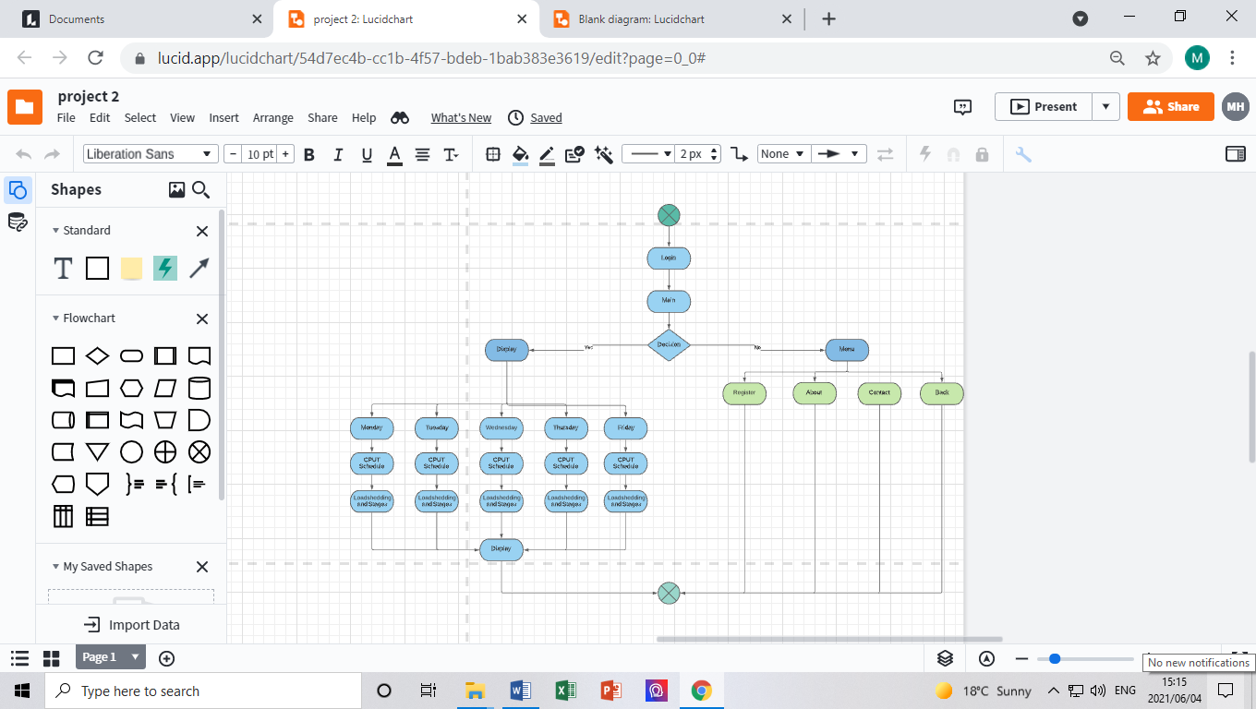

**CODE:**

**MAIN CODE:**

*<?***xml version="1.0" encoding="utf-8"***?>*<**androidx.constraintlayout.widget.ConstraintLayout xmlns:android="http://schemas.android.com/apk/res/android"  
 xmlns:app="http://schemas.android.com/apk/res-auto"  
 xmlns:tools="http://schemas.android.com/tools"  
 android:layout_width="match_parent"  
 android:layout_height="match_parent"  
 android:background="@drawable/dd"  
 tools:context=".MainActivity"**>  
  
 <**androidx.appcompat.widget.Toolbar  
 android:id="@+id/toolbar"  
 android:layout_width="match_parent"  
 android:layout_height="wrap_content"  
 android:layout_weight="1"  
 android:background="?attr/colorPrimary"  
 android:minHeight="?attr/actionBarSize"  
 android:text="Schedule"  
   
 android:theme="?attr/actionBarTheme"  
 android:visibility="visible"  
 tools:layout_editor_absoluteX="0dp"  
 tools:layout_editor_absoluteY="-3dp"  
 tools:visibility="visible"** />  
  
 <**TextView  
 android:id="@+id/textView3"  
 android:layout_width="123dp"  
 android:layout_height="38dp"  
 android:text="Schedule"  
 android:textColor="@color/cardview_dark_background"  
 android:textSize="28dp"  
 android:textStyle="bold"  
 android:visibility="visible"  
 app:layout_constraintEnd_toStartOf="@+id/toolbar"  
 app:layout_constraintHorizontal_bias="0.5"  
 app:layout_constraintStart_toEndOf="@+id/toolbar"  
 tools:layout_editor_absoluteY="5dp"** />  
  
 <**TableLayout  
 android:layout_width="wrap_content"  
 android:layout_height="wrap_content"  
 android:visibility="visible"  
 tools:layout_editor_absoluteX="2dp"  
 tools:layout_editor_absoluteY="55dp"  
 tools:visibility="visible"**>  
  
 <**TableRow  
 android:layout_width="match_parent"  
 android:layout_height="match_parent"**>  
  
 <**TextView  
 android:id="@+id/textView16"  
 android:layout_width="wrap_content"  
 android:layout_height="wrap_content"  
 android:text="Day"  
 android:textColor="@color/white"** />  
  
 <**TextView  
 android:id="@+id/textView7"  
 android:layout_width="wrap_content"  
 android:layout_height="wrap_content"  
 android:padding="10sp"  
 android:text="Subject "  
 android:textColor="@color/white"** />  
  
 <**TextView  
 android:id="@+id/textView9"  
 android:layout_width="wrap_content"  
 android:layout_height="wrap_content"  
 android:padding="10sp"  
 android:text="Time"  
 android:textColor="@color/white"** />  
  
 <**TextView  
 android:id="@+id/textView8"  
 android:layout_width="wrap_content"  
 android:layout_height="wrap_content"  
 android:padding="10sp"  
 android:text="Loadshedding"  
 android:textColor="@color/white"** />  
 </**TableRow**>  
  
 <**TableRow  
 android:layout_width="match_parent"  
 android:layout_height="match_parent"**>  
  
 <**TextView  
 android:id="@+id/textView17"  
 android:layout_width="wrap_content"  
 android:layout_height="wrap_content"  
 android:text="Monday"  
 android:textColor="@color/white"** />  
  
 <**TextView  
 android:id="@+id/textView12"  
 android:layout_width="wrap_content"  
 android:layout_height="wrap_content"  
 android:padding="10sp"  
 android:text="ADP262S"  
 android:textColor="@color/white"** />  
  
 <**TextView  
 android:id="@+id/textView11"  
 android:layout_width="wrap_content"  
 android:layout_height="wrap_content"  
 android:padding="10sp"  
 android:text="9:00-10:00 am"  
 android:textColor="@color/white"** />  
  
 <**TextView  
 android:id="@+id/textView10"  
 android:layout_width="wrap_content"  
 android:layout_height="wrap_content"  
 android:padding="10sp"  
 android:text=""  
 android:textColor="@color/white"** />  
 </**TableRow**>  
  
 <**TableRow  
 android:layout_width="match_parent"  
 android:layout_height="match_parent"**>  
  
 <**TextView  
 android:id="@+id/textView18"  
 android:layout_width="wrap_content"  
 android:layout_height="wrap_content"  
 android:text=""  
 android:textColor="@color/white"** />  
  
 <**TextView  
 android:id="@+id/textView15"  
 android:layout_width="wrap_content"  
 android:layout_height="wrap_content"  
 android:padding="10sp"  
 android:text="ITS262S"  
 android:textColor="@color/white"** />  
  
 <**TextView  
 android:id="@+id/textView14"  
 android:layout_width="wrap_content"  
 android:layout_height="wrap_content"  
 android:padding="10sp"  
 android:text="10:30-11:30 am"  
 android:textColor="@color/white"** />  
  
 <**TextView  
 android:id="@+id/textView13"  
 android:layout_width="wrap_content"  
 android:layout_height="wrap_content"  
 android:padding="10sp"  
 android:text=""  
 android:textColor="@color/white"** />  
 </**TableRow**>  
  
 <**TableRow  
 android:layout_width="match_parent"  
 android:layout_height="match_parent"**>  
  
 <**TextView  
 android:id="@+id/textView34"  
 android:layout_width="wrap_content"  
 android:layout_height="wrap_content"  
 android:text=""** />  
  
 <**TextView  
 android:id="@+id/textView33"  
 android:layout_width="wrap_content"  
 android:layout_height="wrap_content"  
 android:padding="10sp"  
 android:text="ADT262S"  
 android:textColor="@color/white"** />  
  
 <**TextView  
 android:id="@+id/textView32"  
 android:layout_width="wrap_content"  
 android:layout_height="wrap_content"  
 android:padding="10sp"  
 android:text="12:00-13:00 pm"  
 android:textColor="@color/white"** />  
  
 <**TextView  
 android:id="@+id/textView31"  
 android:layout_width="wrap_content"  
 android:layout_height="wrap_content"  
 android:padding="10sp"  
 android:text=""  
 android:textColor="@color/white"** />  
 </**TableRow**>  
  
 <**TableRow  
 android:layout_width="match_parent"  
 android:layout_height="match_parent"**>  
  
 <**TextView  
 android:id="@+id/textView38"  
 android:layout_width="wrap_content"  
 android:layout_height="wrap_content"  
 android:padding="10sp"  
 android:text="Tuesday"  
 android:textColor="@color/white"** />  
  
 <**TextView  
 android:id="@+id/textView37"  
 android:layout_width="wrap_content"  
 android:layout_height="wrap_content"  
 android:padding="10sp"  
 android:text="ICE262S"  
 android:textColor="@color/white"** />  
  
 <**TextView  
 android:id="@+id/textView36"  
 android:layout_width="wrap_content"  
 android:layout_height="wrap_content"  
 android:padding="10sp"  
 android:text="9:00-10:00 am"  
 android:textColor="@color/white"** />  
  
 <**TextView  
 android:id="@+id/textView35"  
 android:layout_width="wrap_content"  
 android:layout_height="wrap_content"  
 android:padding="10sp"  
 android:text=""  
 android:textColor="@color/white"** />  
 </**TableRow**>  
  
 <**TableRow  
 android:layout_width="match_parent"  
 android:layout_height="match_parent"**>  
  
 <**TextView  
 android:id="@+id/textView42"  
 android:layout_width="wrap_content"  
 android:layout_height="wrap_content"  
 android:text=""** />  
  
 <**TextView  
 android:id="@+id/textView41"  
 android:layout_width="wrap_content"  
 android:layout_height="wrap_content"  
 android:padding="10sp"  
 android:text="PRT262S"  
 android:textColor="@color/white"** />  
  
 <**TextView  
 android:id="@+id/textView40"  
 android:layout_width="wrap_content"  
 android:layout_height="wrap_content"  
 android:padding="10sp"  
 android:text="14:00-15:00 pm"  
 android:textColor="@color/white"** />  
  
 <**TextView  
 android:id="@+id/textView39"  
 android:layout_width="wrap_content"  
 android:layout_height="wrap_content"  
 android:padding="10sp"  
 android:text=""  
 android:textColor="@color/white"** />  
 </**TableRow**>  
  
 <**TableRow  
 android:layout_width="match_parent"  
 android:layout_height="match_parent"**>  
  
 <**TextView  
 android:id="@+id/textView46"  
 android:layout_width="wrap_content"  
 android:layout_height="wrap_content"  
 android:padding="10sp"  
 android:text="Wednesday"  
 android:textColor="@color/white"** />  
  
 <**TextView  
 android:id="@+id/textView45"  
 android:layout_width="wrap_content"  
 android:layout_height="wrap_content"  
 android:padding="10sp"  
 android:text="ADF262S"  
 android:textColor="@color/white"** />  
  
 <**TextView  
 android:id="@+id/textView44"  
 android:layout_width="wrap_content"  
 android:layout_height="wrap_content"  
 android:padding="10sp"  
 android:text="9:00-10:00 am"  
 android:textColor="@color/white"** />  
  
 <**TextView  
 android:id="@+id/textView43"  
 android:layout_width="wrap_content"  
 android:layout_height="wrap_content"  
 android:padding="10sp"  
 android:text=""  
 android:textColor="@color/white"** />  
 </**TableRow**>  
  
 <**TableRow  
 android:layout_width="match_parent"  
 android:layout_height="match_parent"**>  
  
 <**TextView  
 android:id="@+id/textView50"  
 android:layout_width="wrap_content"  
 android:layout_height="wrap_content"  
 android:padding="10sp"  
 android:text=""  
 android:textColor="@color/white"** />  
  
 <**TextView  
 android:id="@+id/textView49"  
 android:layout_width="wrap_content"  
 android:layout_height="wrap_content"  
 android:padding="10sp"  
 android:text="CNF262S"  
 android:textColor="@color/white"** />  
  
 <**TextView  
 android:id="@+id/textView48"  
 android:layout_width="wrap_content"  
 android:layout_height="wrap_content"  
 android:padding="10sp"  
 android:text="10:30-11:30 am"  
 android:textColor="@color/white"** />  
  
 <**TextView  
 android:id="@+id/textView47"  
 android:layout_width="wrap_content"  
 android:layout_height="wrap_content"  
 android:padding="10sp"  
 android:text=""  
 android:textColor="@color/white"** />  
 </**TableRow**>  
  
 <**TableRow  
 android:layout_width="match_parent"  
 android:layout_height="match_parent"**>  
  
 <**TextView  
 android:id="@+id/textView54"  
 android:layout_width="wrap_content"  
 android:layout_height="wrap_content"  
 android:padding="10sp"  
 android:text=""  
 android:textColor="@color/white"** />  
  
 <**TextView  
 android:id="@+id/textView53"  
 android:layout_width="wrap_content"  
 android:layout_height="wrap_content"  
 android:padding="10sp"  
 android:text="MAF262S"  
 android:textColor="@color/white"** />  
  
 <**TextView  
 android:id="@+id/textView52"  
 android:layout_width="wrap_content"  
 android:layout_height="wrap_content"  
 android:padding="10sp"  
 android:text="12:00-13:00 pm"  
 android:textColor="@color/white"** />  
  
 <**TextView  
 android:id="@+id/textView51"  
 android:layout_width="wrap_content"  
 android:layout_height="wrap_content"  
 android:padding="10sp"  
 android:text=""  
 android:textColor="@color/white"** />  
 </**TableRow**>  
  
 <**TableRow  
 android:layout_width="match_parent"  
 android:layout_height="match_parent"**>  
  
 <**TextView  
 android:id="@+id/textView58"  
 android:layout_width="wrap_content"  
 android:layout_height="wrap_content"  
 android:padding="10sp"  
 android:text=""  
 android:textColor="@color/white"** />  
  
 <**TextView  
 android:id="@+id/textView56"  
 android:layout_width="wrap_content"  
 android:layout_height="wrap_content"  
 android:padding="10sp"  
 android:text="INM262S"  
 android:textColor="@color/white"** />  
  
 <**TextView  
 android:id="@+id/textView57"  
 android:layout_width="wrap_content"  
 android:layout_height="wrap_content"  
 android:padding="10sp"  
 android:text="14:00-15:00 pm"  
 android:textColor="@color/white"** />  
  
 <**TextView  
 android:id="@+id/textView55"  
 android:layout_width="wrap_content"  
 android:layout_height="wrap_content"  
 android:padding="10sp"  
 android:text=""  
 android:textColor="@color/white"** />  
 </**TableRow**>  
  
 <**TableRow  
 android:layout_width="match_parent"  
 android:layout_height="match_parent"**>  
  
 <**TextView  
 android:id="@+id/textView62"  
 android:layout_width="wrap_content"  
 android:layout_height="wrap_content"  
 android:padding="10sp"  
 android:text="Thursday"  
 android:textColor="@color/white"** />  
  
 <**TextView  
 android:id="@+id/textView61"  
 android:layout_width="wrap_content"  
 android:layout_height="wrap_content"  
 android:padding="10sp"  
 android:text="-"  
 android:textColor="@color/white"** />  
  
 <**TextView  
 android:id="@+id/textView60"  
 android:layout_width="wrap_content"  
 android:layout_height="wrap_content"  
 android:padding="10sp"  
 android:text="-"  
 android:textColor="@color/white"** />  
  
 <**TextView  
 android:id="@+id/textView59"  
 android:layout_width="wrap_content"  
 android:layout_height="wrap_content"  
 android:padding="10sp"  
 android:text=""  
 android:textColor="@color/white"** />  
 </**TableRow**>  
  
 <**TableRow  
 android:layout_width="match_parent"  
 android:layout_height="match_parent"**>  
  
 <**TextView  
 android:id="@+id/textView66"  
 android:layout_width="wrap_content"  
 android:layout_height="wrap_content"  
 android:padding="10sp"  
 android:text="Friday"  
 android:textColor="@color/white"** />  
  
 <**TextView  
 android:id="@+id/textView65"  
 android:layout_width="wrap_content"  
 android:layout_height="wrap_content"  
 android:padding="10sp"  
 android:text="ADP262S"  
 android:textColor="@color/white"** />  
  
 <**TextView  
 android:id="@+id/textView64"  
 android:layout_width="wrap_content"  
 android:layout_height="wrap_content"  
 android:padding="10sp"  
 android:text="10:30-11:30 pm"  
 android:textColor="@color/white"** />  
  
 <**TextView  
 android:id="@+id/textView63"  
 android:layout_width="wrap_content"  
 android:layout_height="wrap_content"  
 android:padding="10sp"  
 android:text=""  
 android:textColor="@color/white"** />  
 </**TableRow**>  
  
 </**TableLayout**>  
  
 <**ImageView  
 android:id="@+id/imageView"  
 android:layout_width="73dp"  
 android:layout_height="32dp"  
 app:srcCompat="@drawable/ic_baseline_menu_open_24"  
 tools:layout_editor_absoluteX="2dp"  
 tools:layout_editor_absoluteY="11dp"** />  
  
 <**ImageView  
 android:id="@+id/imageView3"  
 android:layout_width="61dp"  
 android:layout_height="37dp"  
 app:srcCompat="@drawable/ic_baseline_arrow_back"  
 tools:layout_editor_absoluteX="336dp"  
 tools:layout_editor_absoluteY="11dp"** />  
  
</>

**COLOR CODE:**

*<?***xml version="1.0" encoding="utf-8"***?>*<**resources**>  
 <**color name="purple_200"**>#FFBB86FC</**color**>  
 <**color name="purple_500"**>#0ADDCC</**color**>  
 <**color name="purple_700"**>#FF3700B3</**color**>  
 <**color name="teal_200"**>#05DFCA</**color**>  
 <**color name="teal_700"**>#FF018786</**color**>  
 <**color name="black"**>#FF000000</**color**>  
 <**color name="white"**>#FFFFFFFF</**color**>

</**resources**>

**MAIN ACTIVITY CODE:**

**package** com.example.myapplication;  
  
**import** androidx.appcompat.app.AppCompatActivity;  
  
**import** android.os.Bundle;  
  
**public class** MainActivity **extends** AppCompatActivity {  
  
 @Override  
 **protected void** onCreate(Bundle savedInstanceState) {  
 **super**.onCreate(savedInstanceState);  
 setContentView(R.layout.***activity_main***);  
 }  
}

**FINAL DESIGN:**

In the final design page, this is where I will showcase the final product.

For the functionality of the load shedding part, we as group are still deciding how we are going display the live load shedding times and stages in the main android file.

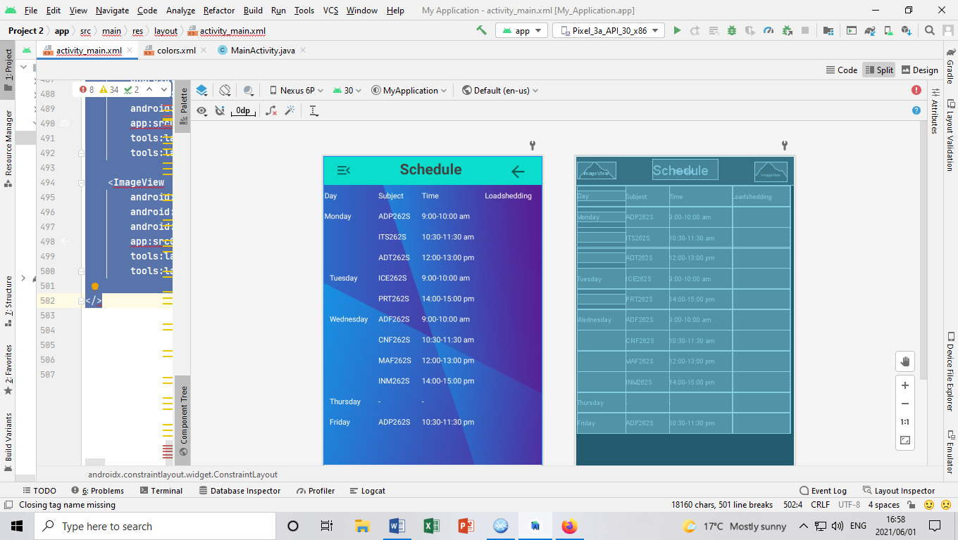

**REFLECTION:**

On the reflection page, this is where I will explain how I designed the page and how the page will work.

In this application, it will have the load shedding times and stages when load shedding is going to occur at district 6 campus. As part of the functionality, the main page will function as follows, the user comes from the login page straight to the main page. On the main page it will display the student or lectures timetables. When load shedding occurs, the user will get a notification to inform that load shedding will occur and it will indicate what stage it will be.

The main page will also have 4 buttons on the toolbar, the four buttons will be Display, Back, Contact and About, which are the other pages. Once the user was informed about the time and the stage of the load shedding the user has the option to go back to the previous page or select another page by clicking on the menu button that is on the toolbar.

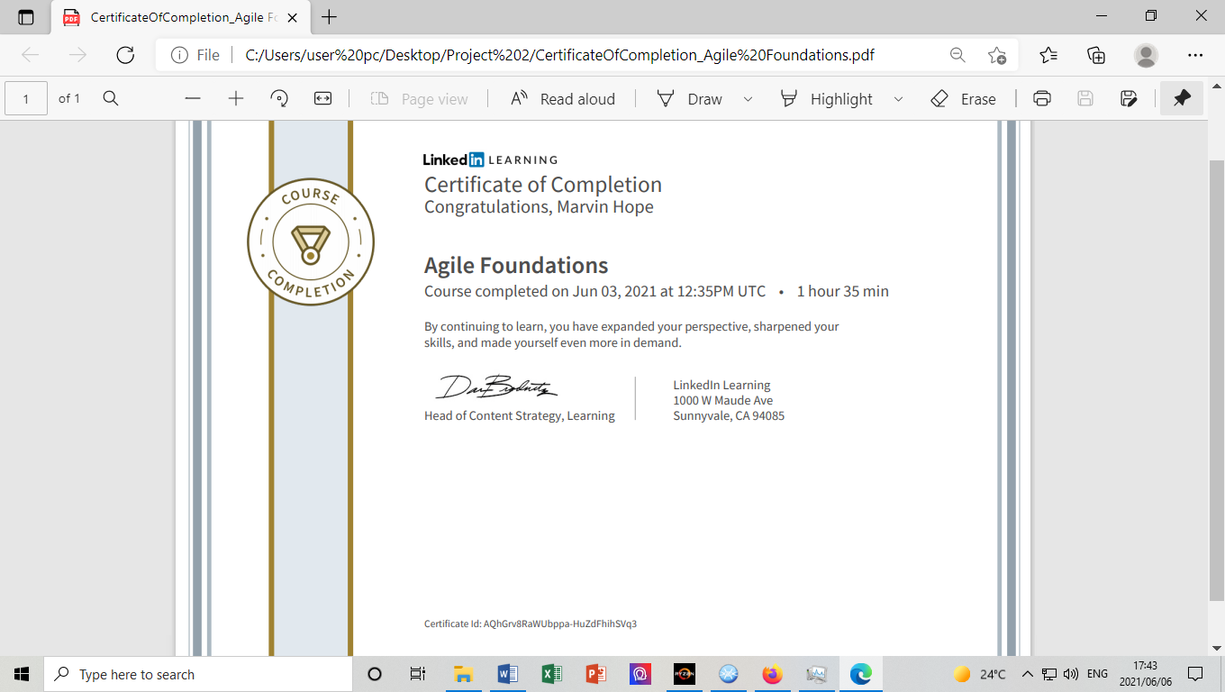**LINKEDLN LEARN:**

**GROUPS GITHUB LINK:**

<https://github.com/Wareezy/Project2-Individual/upload/MarvinHope-219445842>

**PERSONAL GITHUB LINK:**

<https://github.com/Marvinhope24/Project-2.git>

END